Heart Beat Monitor

Software Design Document

Zane Gretz

Tobias Caouette

Date: 12/12/14

Contents

1. Introduction 3

a. Purpose 3

b. Scope 3

c. Definitions and Acronyms 3

2. System Overview 3

3. System Architecture 4

1. Architectural Design 4
2. Design Rationale 4
3. Breadboard prototype 7
4. Band-pass filter schematic 7

4. Human Interface Design 4

1. Overview of User Interface 4
2. Pictures of front interface 5
3. Pictures of internal code structure 6

5. Conclusion and Findings 8

1. Introduction
2. Purpose

This design document describes the architecture and system design of a physical heart beat monitor and interface design of software for human interaction.

1. Scope

The software will attempt to analyze the heartbeat of a person with their finger. Main goal is for an easy to use interface for a person to get accurate heartbeat waves on an intuitive waveform diagram.

1. Definitions and Acronyms

HRM: Heart Rate Monitor

LV: LabView 2014 32-bit

LED: Light Emitting Diode

BEER’s law: Lambert-beer law

BPM: Beats per minute

1. System Overview

The HRM consists of a photo resistor and three red LED’s. The device is simple and beautiful as you place a finger in between the path of the LED’s and Photodiode system the wavelength of the reflected light changes depending on if the blood volume is at its maximum and minimum. When the heart pumps blood through the aorta and then to the extremities including the fingers the light emitted is disrupted and the amount of light absorbed by the new blood volume is defined by the Lambert-Beer Law.

This law states that there is a logarithmic dependence between transmission of light T through a substance and its attenuation coefficient.

*The following equations describe Beer’s law*

Where:

When the finger is illuminated by the LEDs the amount of light absorbed by the tissue using a photoresistor, the amount of blood in the finger can be estimated. As the heart beats, the amount of blood in the finger oscillates, creating an oscillation in the voltage drop of the resistor.

1. System Architecture
2. Architectural Design

The design of the LV program is quite simple and includes a DAQ assistant two waveform graphs a Band pass filter a collector module a statistics module a peak detect module and finally a start stop button.

The signal from the circuit firstly enters the DAQ assistant and the data comes out and goes to a waveform graph to see the raw data. A wire branch takes the raw data and wires it to the Bandpass Filter and the filtered signal goes to a collector module and the collected signal is branched to the Statistics module and the second waveform graph, which displays the processed/filtered signal. The statistics module calculates the heart rate and displays it. The statistics module will be in its very own vi.

1. Design Rationale

The band pass filter was designed to let through frequencies from 1 Hz to 3 Hz. There was a need for a high pass filter due to the need to filter out normal baseline fluctuations and to remove the DC baseline present from our voltage divider, this value corresponds to the lower range of expected heart rates. The low pass threshold was chosen to coincide with the higher expected heart rates and was primarily used to remove noise.

1. Human Interface Design
2. Overview of User Interface

The start stop button is large and easy to distinguish and is to the left of the two waveform diagrams. The top waveform diagram is the unfiltered signal and the larger diagram on the bottom is the filtered and accurate waveform of the heartbeat. To the right of the bottom waveform graph is the final calculation of the heartbeat displayed.

This is the front interface that the user will be interacting with.

It is easy to discern which graph is the raw signal that has a lot of noise included, and directly underneath is the filtered and processed signal.

The integer boxes to the right of the processed signal includes boxes like the Heart rate in the BPM (beats per minute) integer box.

To the right of the BPM is the Stop button which will stop the program from collecting any more data and will leave the last data point on the screen and will reset when the user decides to run the program over again.

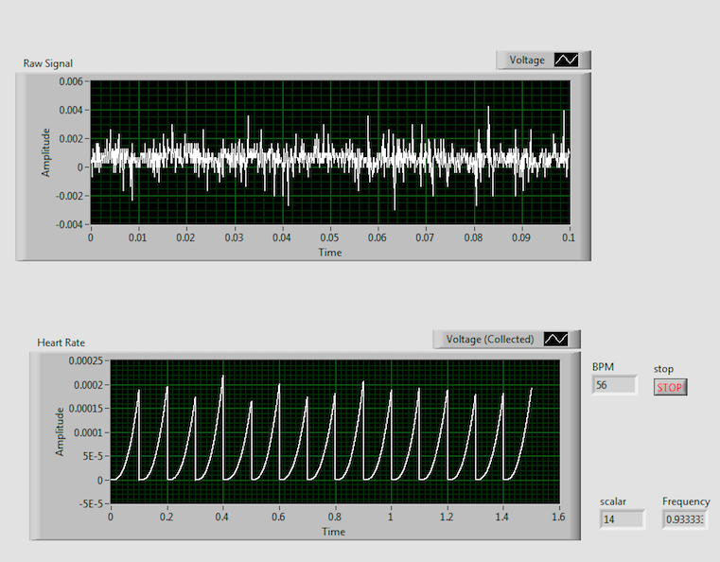

Below is the program:

The program takes the signal from the photo-resistor, which is taken from the DAQ assistant and then displays the raw signal.

The raw signal is then piped to the filter, which is a band-pass filter that filters the upper signal at 3Hz and at the low end at 1Hz.

After the signal is filtered it is then sent to a collector that forks to two different areas.

The first fork it takes is to the Heart Rate signal waveform graph.

The fork also sends the signal to the statistics vi and this takes the maximum reading. The maximum is used to set the threshold of the peak finder vi, we’re looking for peaks within 60% of the

The BPM is measured taking the number of peaks then dividing that by 15, the length of time collected by the collector, to find the frequency and then multiplied by 60 to find the BPM.

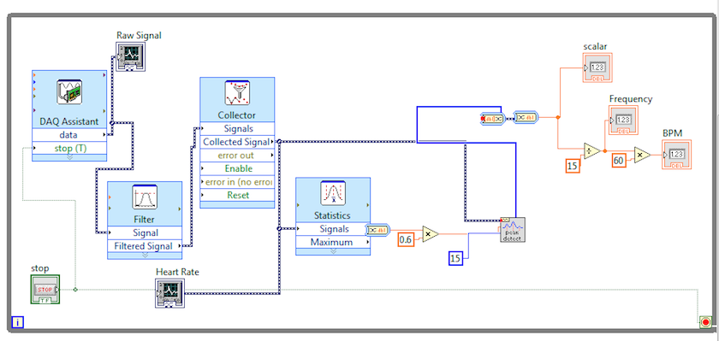

Below is the breadboard prototype of hardware.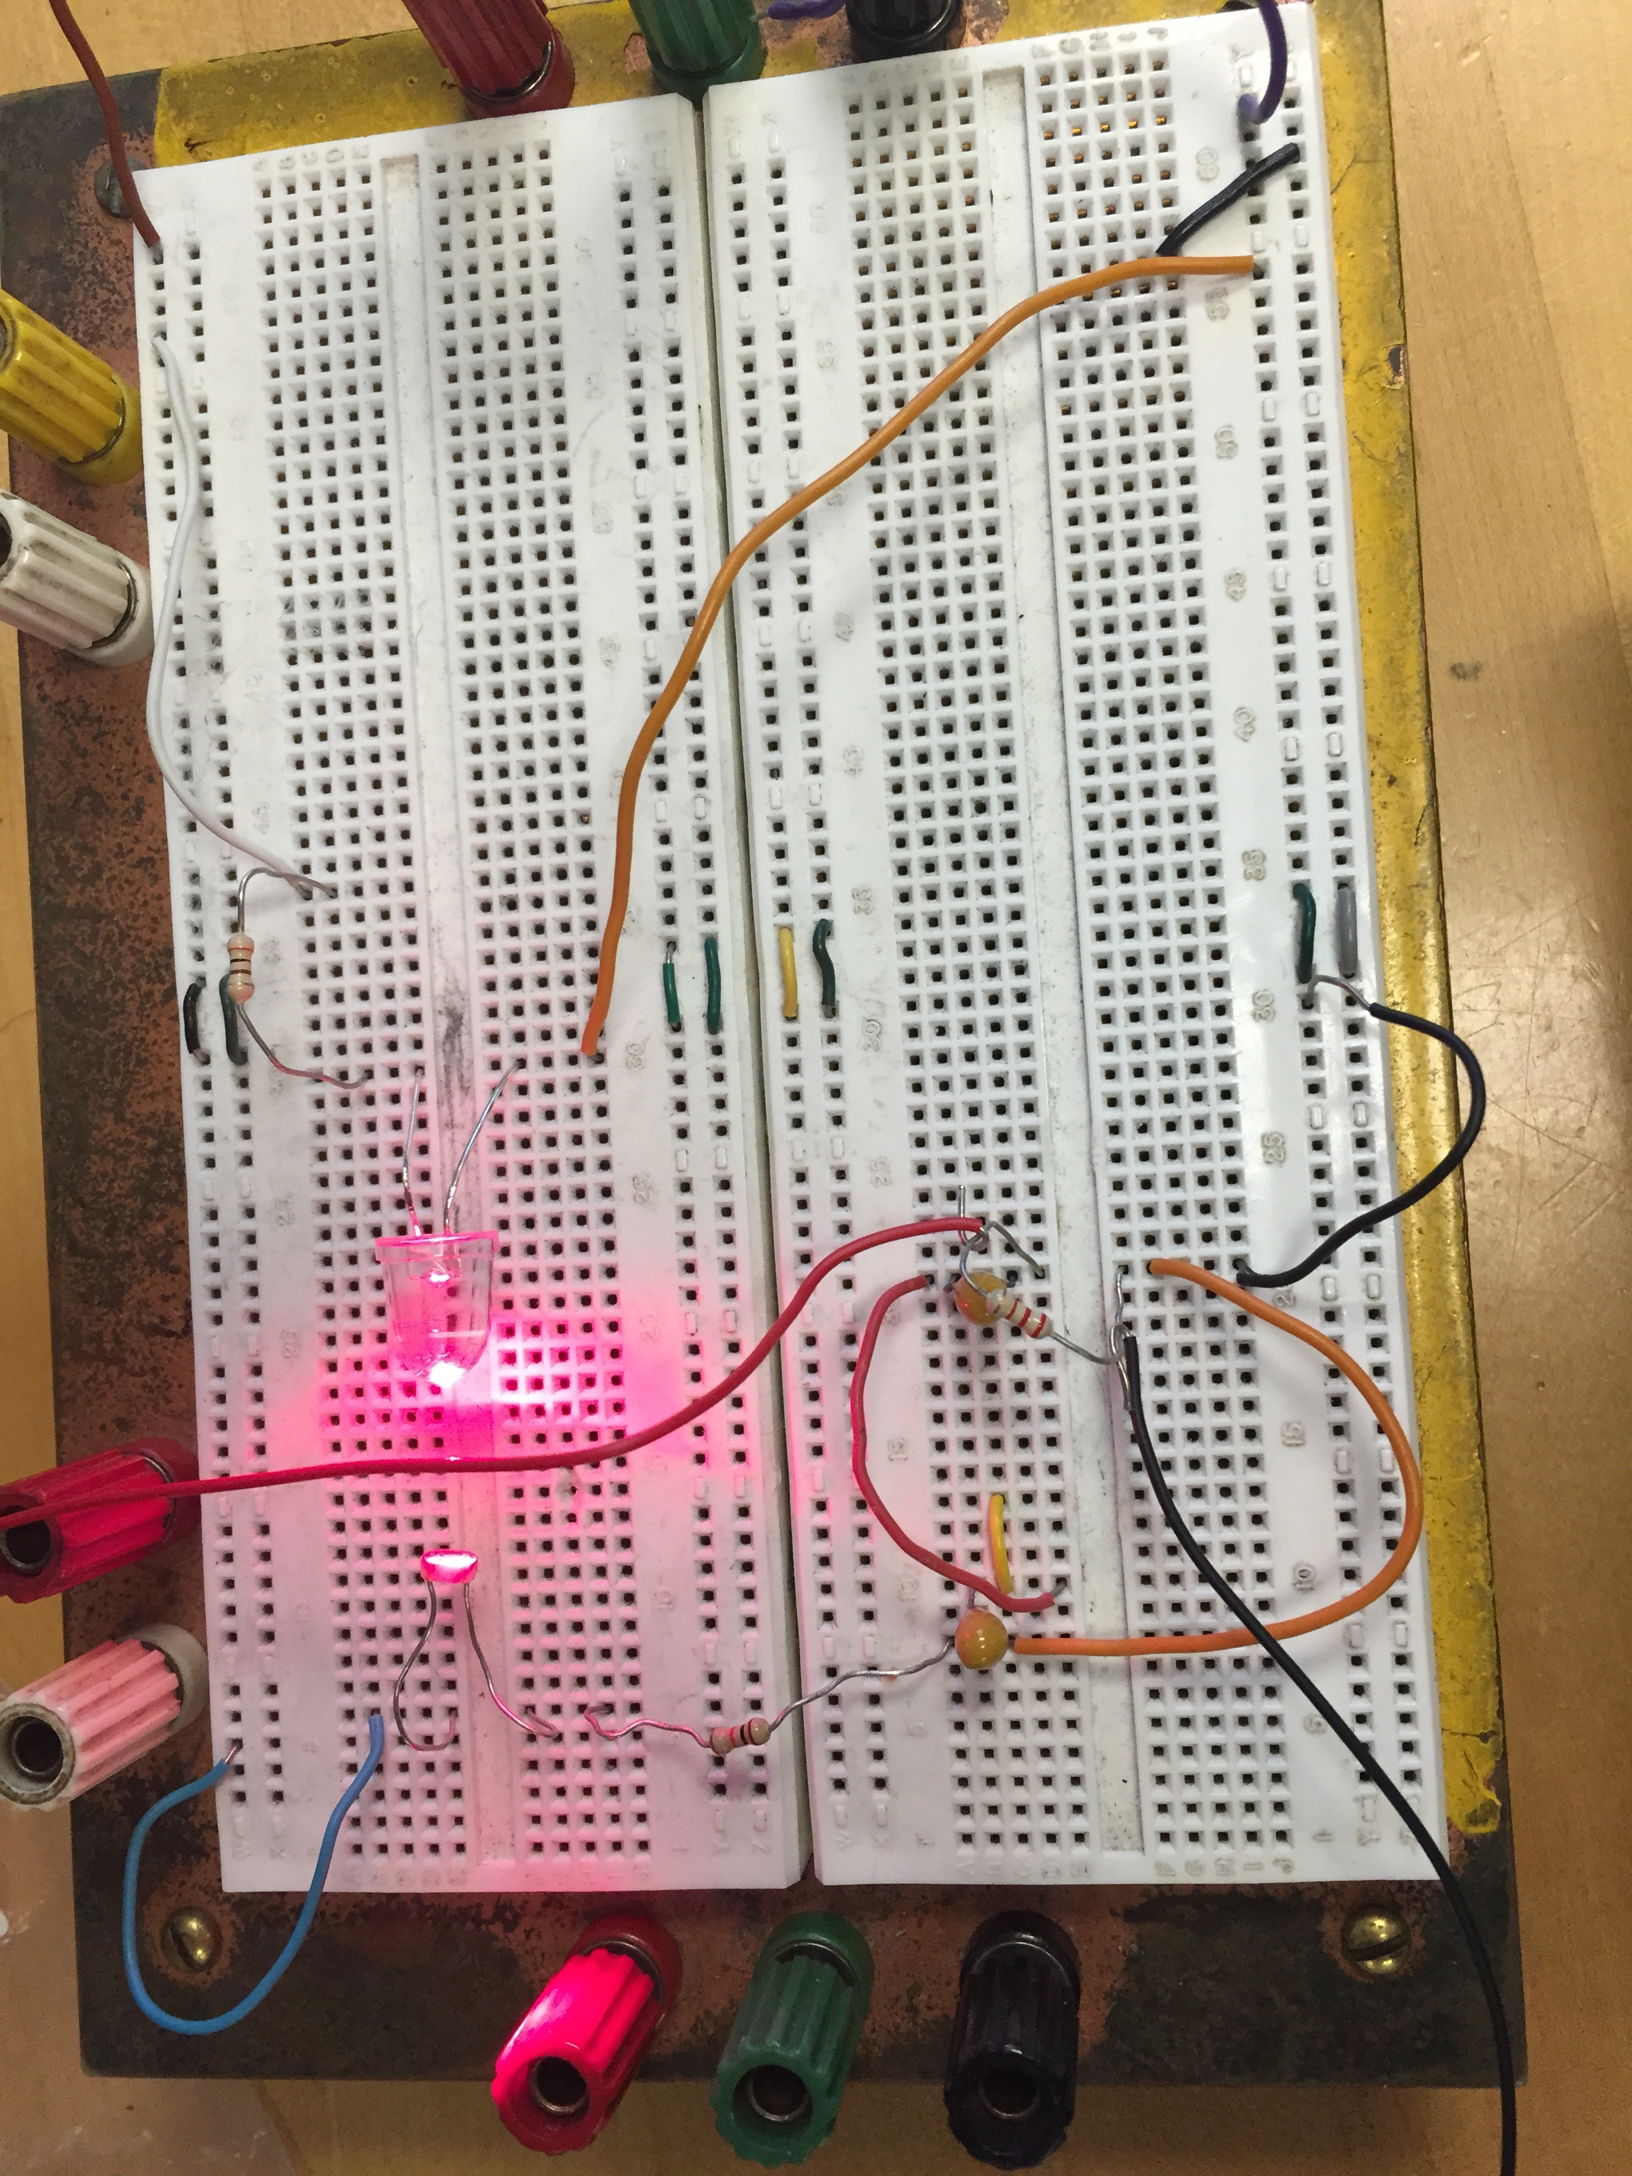

The hard ware setup includes a RC band-pass filter that filters the signal from 1 to 3 Hz.

Below is the circuit diagram of the Band-pass filter. This filter was used as an alternative to the software filter, as an attempt to fix leftover artifact peaks created from the software filter.

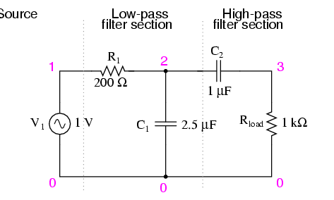

Conclusion and Findings:

After repeated attempts we could not successfully get the desired results of the heart rate monitor.

The issues come from the LED that we were using since the intensity at which they shine wasn’t strong enough. We had a 5000mcd LED and the minimum that we needed was 10000mcd.

We also found that the photo-resistor did not have the proper peak value at 650nm, which is the desired red color, and the ones we attained for the project were at 540nm, which is in the green spectrum.

Without these we cannot say if either of our band-pass filter implementations were working properly or not.

We ended up having very noisy output signals that gave us indiscernible data to which we could not use to find a heart beat. The noise can be attributed to the ambient light in the room, the wiring of the circuit and even the breadboard we were prototyping on. We were successful in seeing a change in measured voltage when a finger was placed in the monitor, but no pulse made it through either band pass filter.

More testing and development is required to make this project work.

Attaining the correct hardware is a must and should be the first next step.

The second step could be isolating the finger-LED-photoresistor system from the ambient light in the room by developing and enclosure that wraps around the finger.

This would limit the noise in the raw data.